**CHAPTER ONE**

**INTRODUCTION**

**1.1 Background to the Study**

The public and private organisations generate staff records. Staff records play an imperative role in providing the information needed by organisations to manage and pay their staff members, plan their workforce requirements and monitor staff and organisations general performance. Ultimately, any organisation’s development and sustainability will depend on sound and effective Human Resource Management (HRM), and the approaches it chooses to follow will be derived in part from an analysis of the information contained in staff records. The goal of staff records management is to ensure that a complete and comprehensive employment history of each employee is readily available for as long as it is needed, and that the information contained in staff records supports the management, deployment, payment and development of staff. Other key objectives of staff records management are to support transparency and organisational accountability and to enable accurate audits by creating and protecting human resource records as reliable evidence (Griffin & Hoyle, 2009).

Organizations need to keep staff information for long periods. For example, retention periods of 70 years or longer for staff files are common in many countries. Thus, staff databases need to store data about individuals for decades – far longer periods that is typical for most database applications. The development of personnel management dates back to the period of World War I around the year 1915 and more recently to the human relations movement of 1935 – 1950 (Cain et al., 2007).

In many offices, records are traditionally kept on paper and in file jackets. However, as the number of records increases, the volume of paper work involved also increases which results to problem of storage spaces. It becomes generally more difficult to manage such a system. Retrieval of information becomes cumbersome. On the account of these shortcomings computerised information storage and management is fast replacing the traditional methods used and the Nigerian Army (NA) will not be left out.

Between 1950 and 1960, a system called Database Management System (DBMS) was invented which provided necessary functionality for maintenance, creation and modification of databases. These systems were however not efficient due to complexity associated with them. A client in database client/server architecture makes an application by requesting for data related services e.g. filtering or sorting from server (Batory, 1988).

This model was first discovered by Dr. Codd who’s aim was to eliminate shortcomings of the previous database management which was mainly huge amounts of information and complexity. Dr. Codd invented relational database management model in 1970 at San Jose Research Laboratory. Sequel or Structured Query Language is one of the most renowned standardised languages for enhancing interaction with a database.

The database is now the underlying framework of the information system, and has fundamentally changed the way many organisations operate. In particular, the developments in this technology over the last few years have produced systems that are more powerful and more intuitive to use (Morgan, 2011). Unfortunately, the apparent simplicity of these systems has led to users creating databases and applications without the necessary knowledge to produce an effective and efﬁcient system (Halpin, 2011).

Relational database system is defined as a database that allows any data visible to the user to be organised in form of tables that allow all operations on them to be possible (Chamberlin, 1990). In recent times, the use of object-oriented designs in manufacture of software has skyrocketed. This has led software engineers to think of ways of coming up with database systems that are object oriented since they are much capable of meeting market needs. At the moment, there is no standardised language that can be used to program relational database systems. The field of relational database is still evolving and stakeholders hope to formalise some standards for object-oriented database systems.

Achievements in database research underpin fundamental advances in communications systems, transportation and logistics, ﬁnancial management, knowledge-based systems, accessibility to scientiﬁc literature, and a host of other civilian and defense applications. They also serve as the foundation for considerable progress in the basic science ﬁelds ranging from computing to biology (Wang, 2011).

**1.2**    **Statement of the Problem**

With large number of works opportunities, the human workforce is increasing, thus, there is a need of a system which can handle the data of such a large number of personnel. Handling of personnel information using the paper method poses a number of challenges. This is evident in procedures and time taken in transferring personnel document while on posting to a new Formation/Unit. The use of paper work in handling some of these processes could lead to human error, papers may end up in the wrong hands and not forgetting the fact that this is time consuming. A number of current systems lack employee self-service meaning employees are not able to access and manage their personal information directly without having to go through their Human Resource (HR) departments or their managers.

Another challenge is that multi-national companies like the NA will have all the personnel information stored at the headquarters of the company making it difficult to access the personnel information from remote places when needed at short notice. The project is aimed at setting up a personnel information system about the status of the employee, the educational background and the work experience in order to help monitor the performance and achievements of the employee through a password protected system.

**1.3** **Aim and Objectives of the Study**

The basic aim of this work is to design and implement an effective and efficient Personnel Information System (PIS) for the NA. To achieve the stated objective, the following specific objectives were laid out:

i. To design of a web-based personnel self-service system to fulfill requirements such as task management; document management, report generation to assist in performance appraisal and employee trainings.

ii. Develop a well secure DBMS for the storage of personnel data.

iii. Create a bi-platform system which aids ease of document retrieval in a case of corruption or system failure at any one end.

iv. Develop a system that will yield timely and quality information to managers for decision making.

1.4 **Scope of the Study.**

The scope of this project will be limited to the following:

i. Personnel profiles: Personnel will have access to their personal profiles and will be able to view and request update of their records from remote areas.

ii. Electronic Document Transfer: Complete elimination of paperwork on the larger implementation on personnel document transfer while on posting.

iii. Document Management: Headquarters are able to assign tasks to formations/Units based on current manpower status and skills.

iv. Report generation: The HRM will be able to generate timely reports in order to monitor personnel and this can be used for performance appraisals. The reports will have all the information of an employee from educational background, trainings attended as well as technical skills.

v. Recruitment Process: The admin will register personnel upon reporting to the Unit. Such personnel will immediately have access to his record using his service and phone numbers as login details. The HRM will then have the ability to add an employee’s information to the database.

1.5    **Significance of the Study**

This work could be useful for personnel managers or officers in an organization as well as those involved in research work on personnel management. This research work would let us know that the success of an organisation largely depends on the assessment and appraisal of individuals and company employee’s potential, performance and how well the organisation can strive to equip all its workers.

Also, this research work will be of immense assistance to the organisational environment because personnel will be able to find the best solution to the various personnel problems as the computerised PIS software will play a very big role in removing the stress in record keeping.

There are many other advantages, and some of them are listed below.

i. It saves a lot of time in processing personnel information.

ii. Database access is fast, reliable and secure in term of authorised access using data encryption and decryption.

iii. Transactions are secured (login page).

iv. It helps in reducing the costs of labour, fixtures and stationery (Paper, files, pens, marker and so on).

**1.6 Limitation of Study**

The major drawback experienced during this project research is during the actual software development. PHP source code required for the algorithm was not easy to obtain, hence the developed system does not include advanced features except those in the scope. Due to time constraint, finance and confidentiality of information, program developed covers aspects such as employment, assessment and retirement. Whatever is left out is as a result of the stated limitations.

**1.7 Definition of Terms**

1. Personnel: Any employee of an organisation.
2. Human Resource: It is a department in an organisation that deals with employee’s records, hiring or retirement.
3. Management: It is the co-ordination of all the resources of an organisation through the process of planning, organization, directing and controlling.
4. System: A method or set of procedures even personnel working together as a whole to achieve a goal.
5. Information: A meaningful material derived from computer data by organising it and interpreting it in a specified way.
6. Information System:A set of interrelated components that collect (or retrieve), process, store and distribute information to support decision making and control in an organisation.

CHAPTER TWO

LITERATURE REVIEW

Literature review for this study will be gathered from various sources in order to learn from others and stimulate new ideas for the study conducted. Literature review will enable the researcher of this study to demonstrate a familiarity with a body of knowledge and establish credibility; to show the path of prior research and integrate the body of knowledge in the context of HRM and leave management.

**2.1 Theoretical Framework**

A theoretical framework comprises the theories expressed by experts in the field into which you plan to research, which you draw upon to provide a theoretical coat hanger for your data analysis and interpretation of results. Put differently, the theoretical framework is a structure that summarises concepts and theories, which you develop from previously tested and published knowledge which you synthesize to help you have a theoretical background, or basis for your data analysis and interpretation of the meaning contained in your research data (Swanson, 2013).

Globally, HRM plays a vital role in achieving an innovative and high-quality product or service in an organisation. The achievements of an organisation widely depend on several significant factors that affect the organisation performance. HRM practices such as training and development, compensation, career planning, employee involvement, and performance appraisal encourage the employees to work better thus, increase the performance of the organisation [(Nabi et al, 2016)](https://www.scirp.org/(S(i43dyn45teexjx455qlt3d2q))/journal/paperinformation.aspx?paperid=102882#ref31).

HRM practices are a process of attracting, motivating, and retaining employees to guarantee the survival of the organisation [(Hassan, 2016)](https://www.scirp.org/(S(i43dyn45teexjx455qlt3d2q))/journal/paperinformation.aspx?paperid=102882#ref19).

With the increasing effect of globalisation and technology, organisations have started to use information systems in various functions and departments in the last decades. HRM is one of the departments that mostly use management information systems (Bal et al, 2012).

In the last 20 years, technology has had a dramatic influence on HRM processes and practices, and a new field has emerged, Human Resource Information Systems (HRIS), which focuses on using technology to support the HR function. A HRIS refers to “a system used to acquire, store, manipulate, analyse, retrieve, and distribute information regarding an organisation’s HR to support HRM and managerial decisions.” (Kavanagh et al, 2015).

Some researchers have also called this new field Electronic Human Resources Management (e-HRM). What started out as a simple mainframe system to automate payroll has now touched all areas of HRM including recruitment, selection, training, and compensation (Stone et al, 2015).

Not surprisingly, these systems have greatly improved many HRM sub-functions and enabled the field to enhance efficiency, decrease administrative burdens, and provide improved service to employees, retirees, and job applicants. Furthermore, the advent of the Internet and new cloud-based technologies have helped HRM achieve the critical goals of attracting talented applicants, streamlining selection processes, facilitating the use of self-service technologies, and allowing organisations to deliver training in remote locations (Johnson et al, 2016).

PIS is a web-based system which stores details of employees in an organisation. It is also known as HRM as it provides all the information related to the employee. It stores information about employees such as personal details, educational qualification, designation, training period, attendance, etc (Parul et al, 2013).

In recent years, information technology has effects on almost every aspect of our society, as well as organisational processes, including HRM processes and practices. From a position associated with administrative management, it has managed to become a strategic partner of organisations, largely because of the use of technologies. Information systems have a deep effect on HRM. It transformed HR processes and practices mainly in terms of how organisations collect, store, use and disseminate information (Marlene et al, 2017).

Continuous innovations in technology will fundamentally change the way HR work is accomplished”. In this context, information technology is seen as the application of computers and telecommunication devices to collect, store, retrieve and disseminate data for business purposes (Stone et al, 2015).

2.2 Empirical Review of the Previous Works on Area of the Study.

The governments of most industrialised nations in the world are investing heavily in research programs to address the issues of conventional paper records, but yet there is no comprehensive technical solution. However, a fundamental strategy is emerging that involves refreshing the storage media, migrating the data onto a new hardware and software; and all necessary steps to validate their integrity, authenticity and addressing issues that has to do with the context of the data which preserve the meaning of the data.

The objective is to retain the ability to display, retrieve, manipulate and use digital information in the face of constantly changing technology. These strategies require the development of highly specialised techniques which are also often relatively expensive. The management of these electronic records is a relatively new issue for developing countries, but the governments are already beginning to address these challenges.

The empirical review of this study is a way of reviewing various literatures relevant to this study thereby giving more idea to the researcher.

Innumerable research studies have been undertaken to understand the technological implications on HRM in general. The Present review deals with some of the noteworthy empirical studies found through scholarly Internet Search engines like scholargoogle.com and several online databases like INFODATA, docstoc.com, Wikipedia and others) related to the impact of E-technology on HRM. These developments, in turn, necessitate certain structural modification including a change from physical to information technology, capital-centered to human-centered economy, and conflict to cooperative working relationships (Nenwani & Raj, 2013).

In this framework, the Internet and technology usage became indispensable for the HRM as much as for the overall functioning of organisations. For this reason, e-HRM has emerged to be a driving force behind HRM value creation (Ruël and Kaap, 2012).

The rapid development of the Internet during the last decade has also boosted the implementation and application of e-HRM. According to the Surveys of the HR consultants suggest that both the number of organisations adopting e-HRM and the depth of applications within the organisations are continually increasing. In addition, an escalating number of practitioner reports provide anecdotal evidence that e-HRM is becoming increasingly common and may lead to remarkable changes (Nivlouei, 2014).

The e-HRM applications have a significant positive effect on the effectiveness of HRM activities. This means that deploying e-HRM tools impacts on the effectiveness of HRM activities indirectly. For implementing e-HRM tool, first we must identify the goals and strategies of e-HRM and then provide the infrastructure in organisation such as information technology and telecommunication systems. It is essential to consider the limitations of implementing e-HRM such as hardware, software, employees’ skill and financial capabilities (Ruël & Bondarouk, 2013).

An empirical study shows that technology solutions can help tech Savvy HR professionals to strategically manage through the crisis and prepare as the climate shifts to the upside. Trends that we will follow in later years include managing and developing talent, embracing HRM analytics, Web 2.0 adoption, and HR technology strategy (Nenwani & Raj, 2013).

**2.3 Conceptual Framework**

A conceptual framework is the total, logical orientation and associations of anything and everything that forms the underlying thinking, structures, plans and practices and implementation of your entire research project. So, the conceptual framework comprises your thoughts on identification of the research topic, the problem to be investigated, the questions to be asked, the literature to be reviewed, the theories to be applied, the methodology you will use, the methods, procedures and instruments, the data analysis and interpretation of findings, recommendations and conclusions you will make (Ravitch & Riggan, 2017).

e-HRM has been defined as a set of ‘configurations of computer hardware, software and electronic networking resources that enable intended or actual HRM activities (e.g. policies, practices and services) through coordinating and controlling individual and group-level data capture and information creation and communication within and across organisational boundaries’ (Marler & Parry, [2015](https://www.tandfonline.com/doi/full/10.1080/09585192.2016.1245672))

The e-HRM review departed from the perspective of the Information Systems literature in multinational corporations (Ruël and Bondarouk, [2013](https://www.tandfonline.com/doi/full/10.1080/09585192.2016.1245672)). The analysis of 53 articles led to the conclusion that e-HRM research in multinational corporations was mostly focused on the adoption of systems and end-user satisfaction with e-HRM (Geffen et al, [2013](https://www.tandfonline.com/doi/full/10.1080/09585192.2016.1245672)).

The examination of 40 e-HRM studies from 1999 to 2011, with a goal to ‘apply an integrative evidence-based framework to ascertain what e-HRM and strategic HRM relationships were supported in the literature’. They concluded that there was very little systematic evidence concerning whether e-HRM was related to strategic outcomes, but there was considerable evidence advocating the moderating role of contextual factors in these relationships (Marler and Fisher, [2013](https://www.tandfonline.com/doi/full/10.1080/09585192.2016.1245672)).

An overview of the challenges ahead of e-HRM research based on the findings of publications between 2009 and 2012, where they observed that, despite all the effort, e-HRM studies still did not address the full complexity of e-HRM projects (Ruël & Bondarouk, [2014](https://www.tandfonline.com/doi/full/10.1080/09585192.2016.1245672)).

There were explanations that the field still lacked theoretical in-depth developments. The latest review in this profound list was conducted where the authors included both, academic and professional developments. Their examination of the mainframe, client server, ERP and web-based systems, and cloud-based systems led to the surprising conclusion that much of the research on the use of technology to support HRM has occurred only within the last 15–20 years and has come in response to the use of the web as a medium for the delivery of HRIS (Johnson et al, [2016](https://www.tandfonline.com/doi/full/10.1080/09585192.2016.1245672)).

These technology developments made it possible to create a real-time information-based and interactive work environment. PIS have evolved from the automated employee record keeping into more complex reporting and decision systems (Boateng, 2017).

Basically, an Information System handles the flow and maintenance of Information that supports a business or some other operation. It contains information about significant people, places and things within the organisation or in the environment surrounding it. Information is derived from meaningful interpretation of data. Information systems have increased the efficiency of HRM through more effective recruitment methods, organisational communication, employee involvement, and increased skills of HRMs (Wilkerson, 2015).

A system which assembles, stores, processes, and delivers information relevant to an organisation (or to a society), in such a way that the information is accessible and useful to those who wish to use it, including managers, staff, clients and citizens. An information system is a human activity (social) system, which may or may not involve the use of computer systems. “An automation system is a precisely planned change in a physical or administrative task utilising a new process, method, or machine that increases productivity, quality and profit while providing methodological control and analysis. The value of system automation is in its ability to improve efficiency; reduce wasted resources associated with rejects or errors; increase consistency, quality and customer satisfaction; and maximise profit” (Kaur, 2013).

Also, in addition to supporting decision-making, information systems help workers and managers to analyze complex problems, to develop new products and to integrate the various modules and departments. Moreover the 'transmission losses inter-departmental communication are reduced considerably leading to better coordination and improved transparency (information sharing) within the organisation as a whole (Bondarouk et al, 2017).

Research carried out by CIPD (2018) suggests that data security concerns the process of safeguarding

employees’ personal information (i.e. payment information, contract terms and career history). Data security has evolved considerably over previous years and is now a core, staple element of any successful strategy in modern HRM.

Blumash, (2018) explains that it is not “the need to collect information relating to hiring, promoting and firing employees” which has changed, but instead how securely this information is stored. Modern HRM can be classified as composite of the following three elements; HR actors, HR activities and HR technologies (Parry & Tyson, 2013).

Research carried out suggests that data security concerns the process of safeguarding employees’ personal information (i.e. payment information, contract terms and career history). Data security has evolved considerably over previous years and is now a core, staple element of any successful strategy in modern HRM (CIPD, 2018).

The formation of General Data Protection Regulation (GDPR) in 2018 is another example of how data security has tangibly influenced the evolution and development of HRM in recent years. GDPR was set up by the European Union to give individuals more rights in relation to personal data protection. This has impacted organisations in terms of data retention, usage, security and transparency (Arden, 2017).

2.4 Review of Related Work

**2.4.1 Oracle HRM Systems**

This software or hardware is developed for general use in a variety of information management applications. It is not developed or intended for use in any inherently dangerous applications, including applications that may create a risk of personal injury. (Arur et al, 2021).

In terms of the applications itself, Oracle HR and PeopleSoft are rated as one of the best HRIS software endorse (Al-Tarawneh and Tarawneh, 2012).

In particular, there is the claim that PeopleSoft is commonly used by a big organisation since this application offers a comprehensive premium package which significantly develop its HRIS capabilities. However, this software can be cost consuming as the software package would comprise of hardware, software, maintenance and training cost (Armstrong and Taylor, 2014).

Oracle Self-Service Human Resources (SSHR) enables your workforce to use a web browser to access HR information and perform personnel actions. The information an individual can access is tailored to the individual's roles and information needs. You can: authorize employees to maintain their own information, including personal profiles, benefits, and expenses; enable managers to conduct performance reviews, transfers, and time and expense approval; and deliver workforce intelligence to managers, HR professionals, and executives. Oracle SSHR is designed for the needs of the casual or untrained user, with simple, intuitive navigation and configurable user assistance integrated with the user interface (Arur et al, 2021).

**2.4.2 PeopleSoft Human Capital Management System**

Your workforce is one of your key assets and a crucial contributor to your organisation’s success. With Oracle’s PeopleSoft Human Capital Management, you can manage your entire workforce holistically, address your organisation’s talent management needs and maximise employee productivity and efficiency. PeopleSoft Core HR sits at the center of PeopleSoft Human Capital Management, enabling you to securely access your employee information and manage essential HR functions effectively

Simple and Easy to Use PeopleSoft HCM delivers a clean, consistent and user-friendly design, resulting in greater user satisfaction that leads to higher adoption without the high cost of training employees. (Arur et al, 2021).

**2.4.3 Orange HRM**

Orange HRM is a powerhouse HR tool that any small or midsize business can benefit from using. With Orange HRM, you have options: You can download and install the system on your own hardware, or you can purchase a hosted solution. Orange HRM's features include: fully modular, addons (e.g., benefits, employee self-service, training, budget, job and salary history, etc.) for purchase, all standard HR functions (employees, leave, benefits, performance, etc.), and more (Wallen, 2013).

**2.4.4 Simple HRM**

Simple HRM offers an open-source version of its professional platform. This version offers time management, and it can be installed on either a WAMP (Windows Apache MySQL PHP) or LAMP (Linux Apache MySQL PHP) server. Once installed, Simple HRM offers every feature you need to solidify your HRM department: employee information, leave management, travel management, expense management, benefit management, and task reporting. Simple HRM allows you to assign a CV to an employee and define eligibility for rehire. Each major module offers plenty of granular control, and the user interface is well laid out (Wallen, 2013).

**2.4.5 Waypoint HR**

Waypoint HR is the HR software for any small or midsize company looking for a platform that nearly any user, of any experience level, can use. Waypoint HR can manage employee data, which include: personal details, holiday/sickness/absence history, employment/contract/job/salary details, discipline and grievance records, performance appraisals, exit interviews and termination, a five-step add employee wizard, export reports to PDF and multi-site facility layering (Wallen, 2013).

**2.5 Summary of Literature Review**

The literature review in this chapter has looked at a brief overview of existing HR and Employee Management Systems and what procedures have to be followed when executing these HR tasks. It helped the researchers get the various possible ways through which the research problem can easily be solved to upgrade existing systems. Also, several systems related to the proposed system were also reviewed as well in this chapter hence serving as a framework to developing a system that will efficiently solve the stated problem.

The literature review of this project analysed various works carried out in the field of HRM, the importance of security over the Internet and suggested ways in which a web application can be made secure. The next chapter will take a look at the system analysis of the developed system.

**CHAPTER THREE**

**METHODOLOGY AND SYSTEM ANALYSIS**

**3.1 Methodology of the Research**

Methodology is a body of methods, rules, and postulates employed by a discipline. The methodology employed in an experiment is essential to its success, and bad methodology has spoiled thousands of research projects. So, whenever a piece of research is published in a scientific journal, the researchers always carefully describe their methodology; otherwise, other scientists couldn't possibly judge the quality of what they have done.

The methodology used in this research is Boehm’s Spiral Methodology (BSM). BSM is essential for the development of information systems because its steps are flexible enough for researchers to work with.

**3.2 Methods of Data Collection**

In this study, necessary information about the existing system were acquired so as to adopt a way of designing the new system through the following methods:

**3.2.1 Interview Method**

This involves a face-to-face discussion with the Admin/Personnel staff. Questions were asked and responses received which determined how personnel functions are carried out base on the responses to the questions asked by the researchers. It is obvious that the Admin/Personnel department of NA Units operates using the traditional paper methods of file handling.

**3.2.2 Observation Method**

During ­­­this research, observations were made on how the NA at Unit level manages its personnel records from recruitment to retirement. It was observed that data are collected from personnel using papers periodically or as need arises and same forwarded to higher headquarters quarterly. Despite this routine activity, personnel information is not always readily available when needed as observed during promotions, posting as well as during welfare needs such as leave and family emergencies. Also, observation was made on how personnel information is retrieved, transferred, updated and processed throughout their service years. This process is however time consuming, stressful, costly and ineffective thereby causing poor personnel information management in the NA.

**3.2.3 Other Methods**

This involves other sources through which data relevant to the area of study was derived. Forms relating to personnel record update was retrieved from Unit offices. As well, so many websites were visited over the internet in other to derive meaningful data that will aid in actualising the proposed system.

**3.3 Analysis of the Existing System**

The existing system is operated using paper method. Personnel information is stored in MS Excel spreadsheets and paper files in cabinets. On the management side, they may have to go through loads of files in order to retrieve or update personnel information through their service years in the NA. Also, the management have to physically transfer personnel documents to new Units upon posting from their present Units. It also uses phone call to reach previous Unit(s) of a staff in order to verify information or confirm status. However, most staff grow too curious as to know whether their documents were updated, this makes them to regular come to the record offices in order to check and determine the current status of their files.

**3.3.1 Advantages of the Existing System**

The existing system has some advantages which includes:

i. No technology required to update the system.

ii. Elimination of unauthorized access

iii. Does not require specialized knowledge for its operation.

iv. Data entry errors are minimized.

**3.3.2 Disadvantages of the Existing System**

The paper method of personnel information management poses a number of challenges which include:

1. The speed of processing data in the existing system is slow and prone to errors.
2. So many files, papers, drawers, filing cabinets are used. These occupy space and makes data transfer cumbersome.
3. There are no adequate security measures employed in any manual system of data processing and storage. As a result of this, some confidential files and documents could consciously or unconsciously be exposed and these files are not properly checked and restricted.
4. Slow and inefficient database system which lacks cohesion.
5. The lack of a central database that is directly accessible by staff and management in its decision-making procedures.

**3.4** **Analysis of the Proposed System**

The new system project a computerised method of managing personnel in an organisation. For a big organisation like the NA, this system will help to solve all the problems inherent in the existing system. This means, the process through which staffs files are managed by the management is done electronically. In the proposed system, personnel of the NA will have to fill a form on a web platform electronically in order to view their records and request for document updates. Also, the management of the organization will have to manage the documents on same web platform electronically and notification sent to the affected personnel(s). The proposed system serves as a correction to the existing problems being encountered by the NA on the basis of personnel information update, retrieval and management.

**3.4.1 Advantages of the Proposed System**

The justification for the new system includes:

i. Timely staff record registration.

ii. Timely processing of personnel information.

iii. Error-free processing of data.

iv. Ease of update and information retrieval.

v. Timely and effective transfer of personnel document upon transfer.

vi. It is inexpensive to administrators.

vii. Transactions are secured (Authentication).

viii. It is cost effective.

**3.4.2 Disadvantages of the Proposed System**

The disadvantages of the proposed system include:

i. Human error during information input.

ii. Costly technology to update your system.

iii. Requires specialized knowledge.

**3.5 System and Program Flowchart**

A system flowchart is a diagram which uses a set of standard graphic symbols to represent the sequence of coded instructions fed into a computer, enabling it to perform specified logical and arithmetical operations. The flowchart of the proposed system is as drawn in figure 1 below.

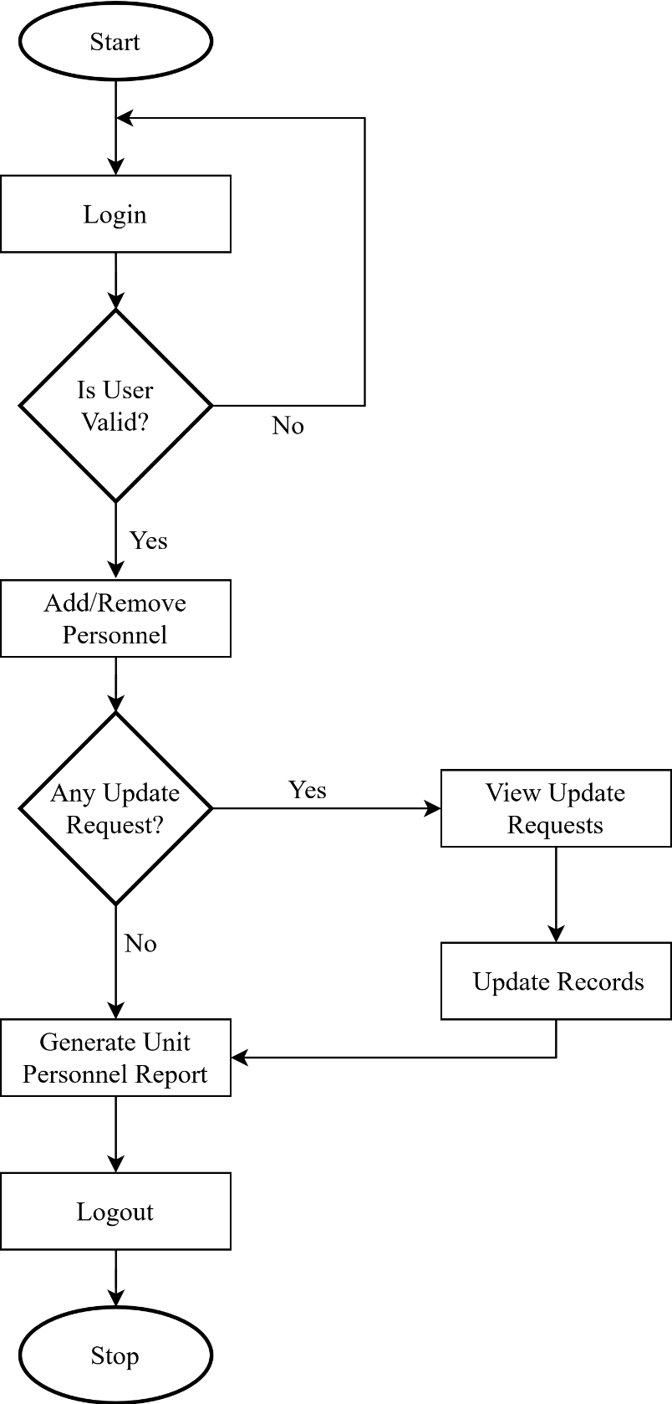

***Figure 1.1:*** *Admin System Flowchart of the Proposed System*

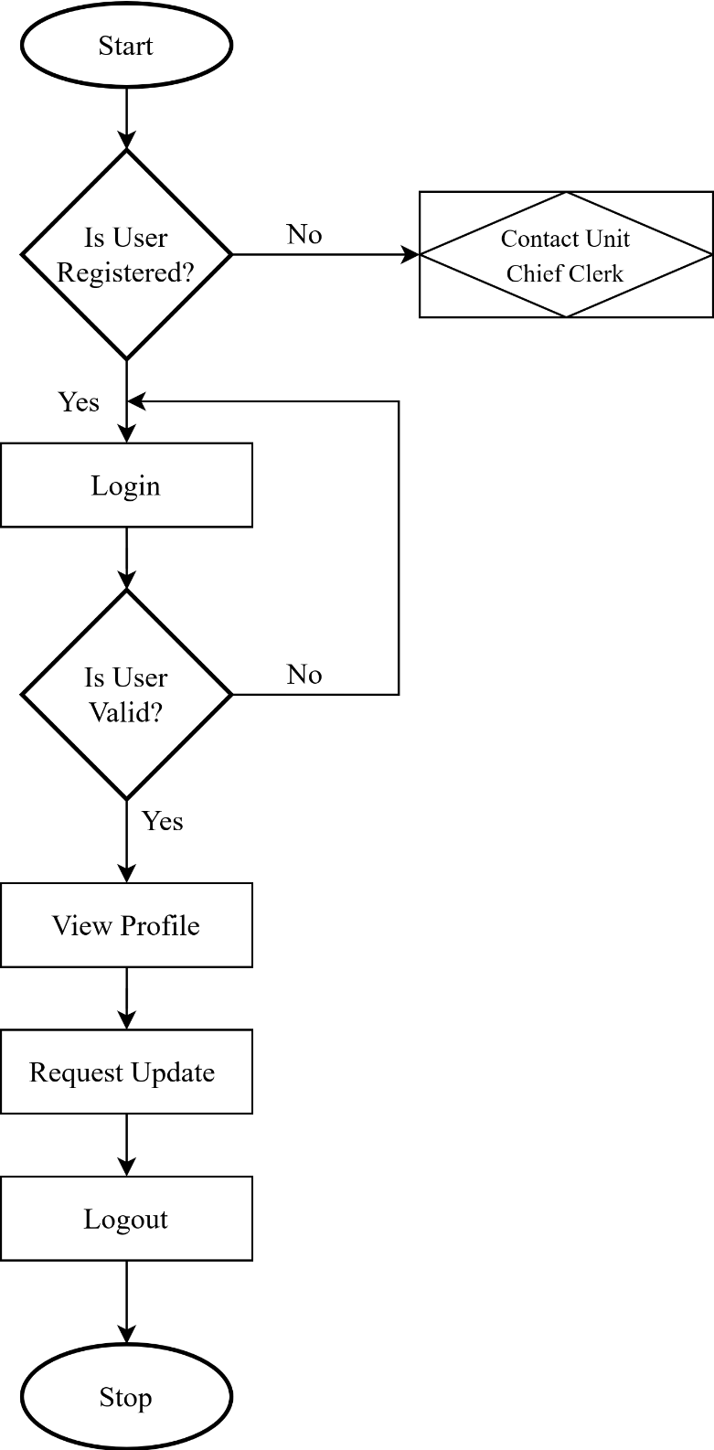

***Figure 1.2:*** *Personnel System Flowchart of the Proposed System*

**3.6 High Level Model of the Proposed System**

High level models are simple models with the primary goal to support understanding, analysis, communication and decision making. The models have different complementary representations and formats, e.g., visual diagrams, mathematical formulas, and quantitative information and graphs. The high-level model of the proposed system is as drawn in figure 2 below.

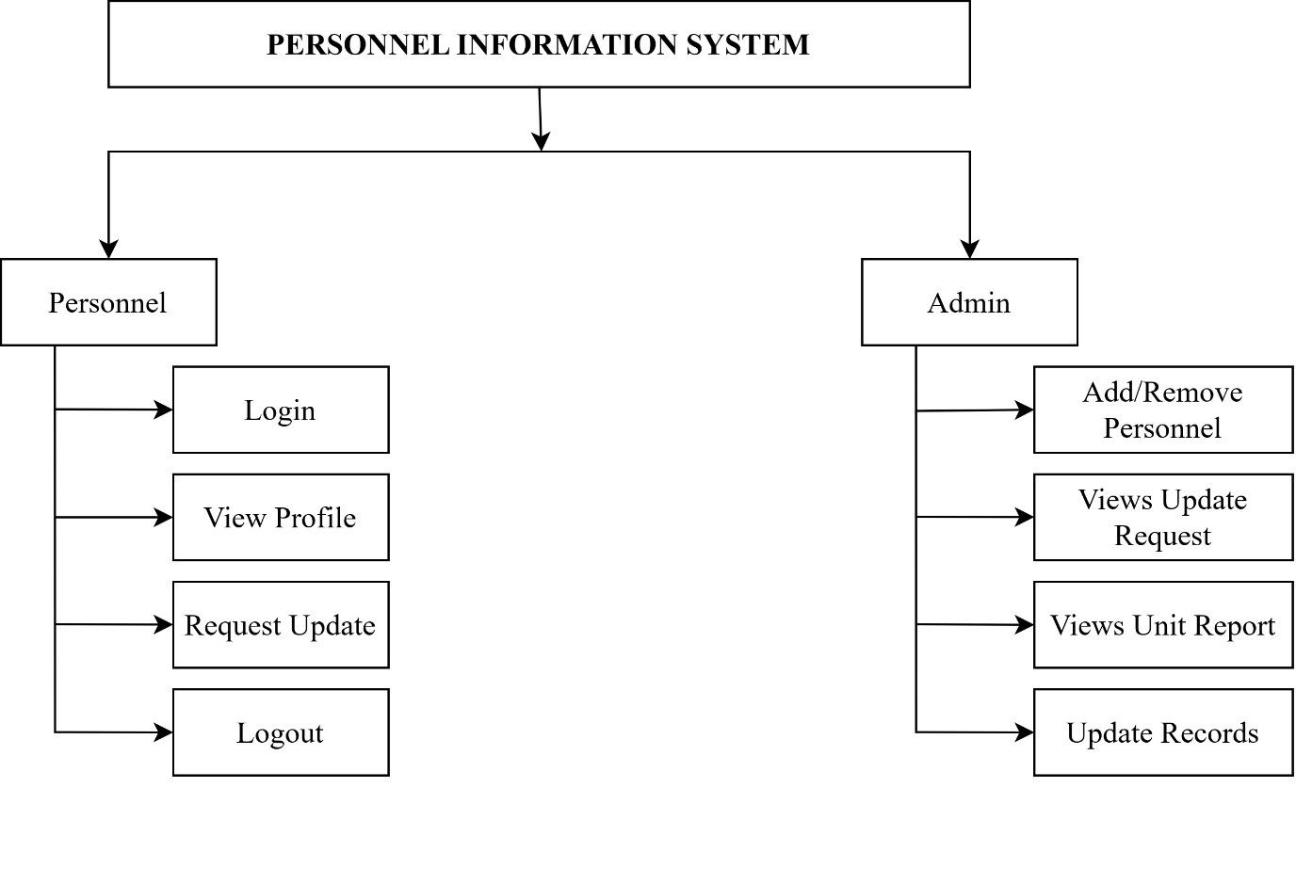

***Figure 2:*** *High Level Model of the Proposed System*

**3.7 Database Design**

A database is a collection of information that is organized so that it can be easily accessed, managed and updated. Database designs physically show the structure of a database in order for one to understand the database without accessing it.

According to Modum (2000), “The advantages of an electronic database are numerous. It provides for mass storage of all the organisation’ relevant data in a structured manner, in such a way as to eliminate redundancy”. Therefore, good organization of data is vital and unnecessary information repetition of data/information would be avoided. The database used in the proposed system is MySQL.

**3.7.1 The Database Table Layout**

A table is a collection of related records and a record is a collection of related fields, and a field a collection of characters (Adams, 2000). The tables used for during the database development of this research work is:

1. **Structure for File “Staff”**

|  |  |  |
| --- | --- | --- |
| FIELD NAME | **DATA TYPE** | **SIZE** |
| ID | Varchar | 20 |
| Army Number | Varchar | 20 |
| Rank | Varchar | 20 |
| Name (Firstname, Surname, Other Names | Varchar | 30 |
| Address: | Varchar | 60 |
| Date of Birth | Date\Time | 8 |
| Sex | Varchar | 10 |
| Age | Varchar | 4 |
| Status | Varchar | 20 |
| Height | Varchar | 10 |
| Date of Enlistment | Date\Time | 8 |
| Qualification (Military/Civil): | Varchar | 20 |
| Date of Last Promotion | Date/Time | 8 |
| Next of Kin | Varchar | 30 |

***Table 1:*** *Structure for file “staff”*

**3.8 Unified Modelling Language Diagram**

Unified Modeling language (UML) is a standardized modeling language enabling developers to specify, visualize, construct and document artifacts of a software system. There are various diagrams under UML. However, class diagram, use case diagram and activity diagram are used in this research work to better define the proposed system.

**3.8.1 Use Case Diagram**

A use case diagram defines a goal-oriented set of interactions between external users and the system under consideration or development. Thus, a Use Case Scenario is a description that illustrates, step by step, how a user is intending to use a system, essentially capturing the system behavior from the user's point of view.

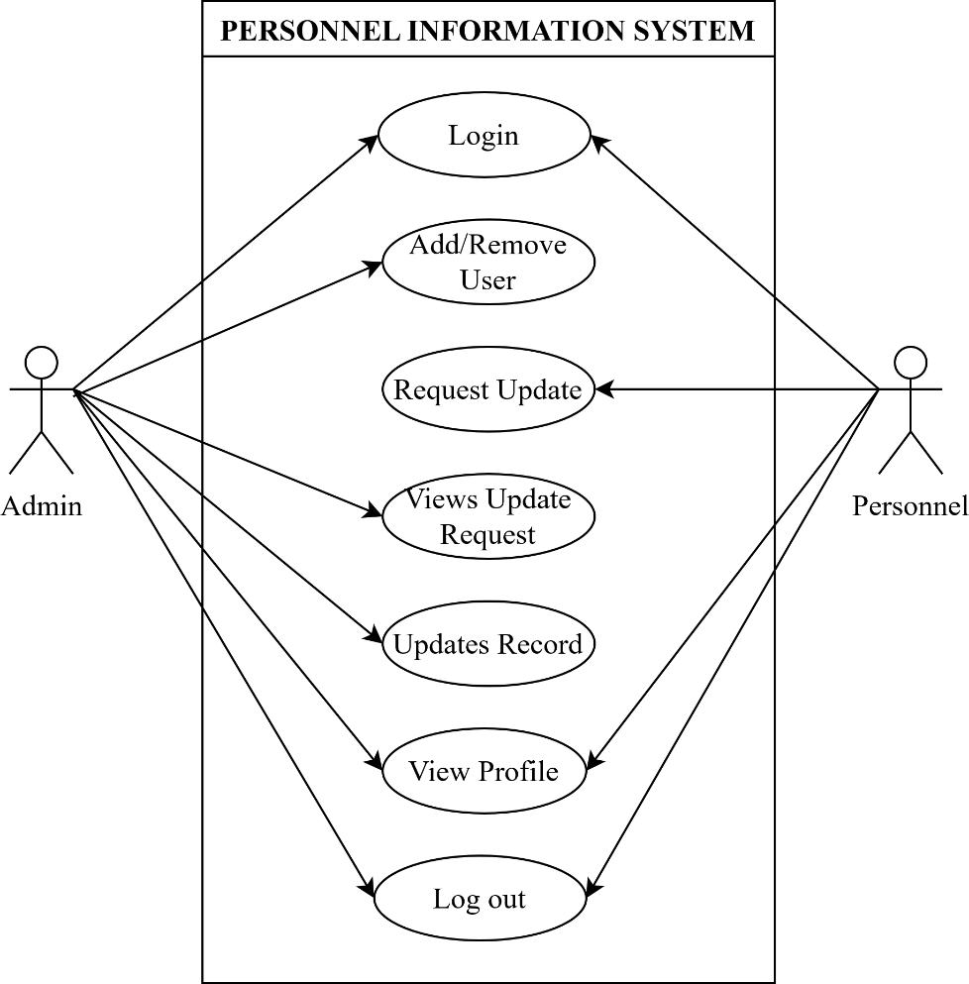

***Figure 3:*** *Use Case Diagram of the Proposed System*

In order to create relevant use cases for the system, the following actors for the system have been identified:

|  |  |  |
| --- | --- | --- |
| **Actor** | **Use Case** | **Description** |
| Personnel | View Profile | Personnel will be able to view their records stored by the admin in the database from remote locations using their assigned login details. |
| Apply for Records Update | Personnel will be able to submit request for update of specific records through the online platform. |
| Print Records | Records can be printed by the personnel when needed for personal record keeping. |
| Admin | Add New Personnel | Admin will be able to add newly posted-in personnel to the Unit database. |
| Delete Personnel | Personnel posted out of the Unit can be removed from the database. |
| Update Records | Admin will be able to update personnel information based on request by such personnel either physically or through the online platform. |
| Generate reports | HR will be able to generate reports containing personnel information. |

***Table 3:*** *Actors Use Cases and their Description*

3.8.2 **Class diagram**

In computer science, a class diagram in the UML is a type of static structure diagram that describes the structure of a system by showing the system's classes, their attributes, operations (or methods), and the relationships among objects.

In the class diagram below, the Personnel and Admin classes inherit from the User class. An admin may include the Commanding Officer, Adjutant/AO, Chief Clerk, Record Clerk and Computer Operator that have direct access and interacts with the system with many privileges.

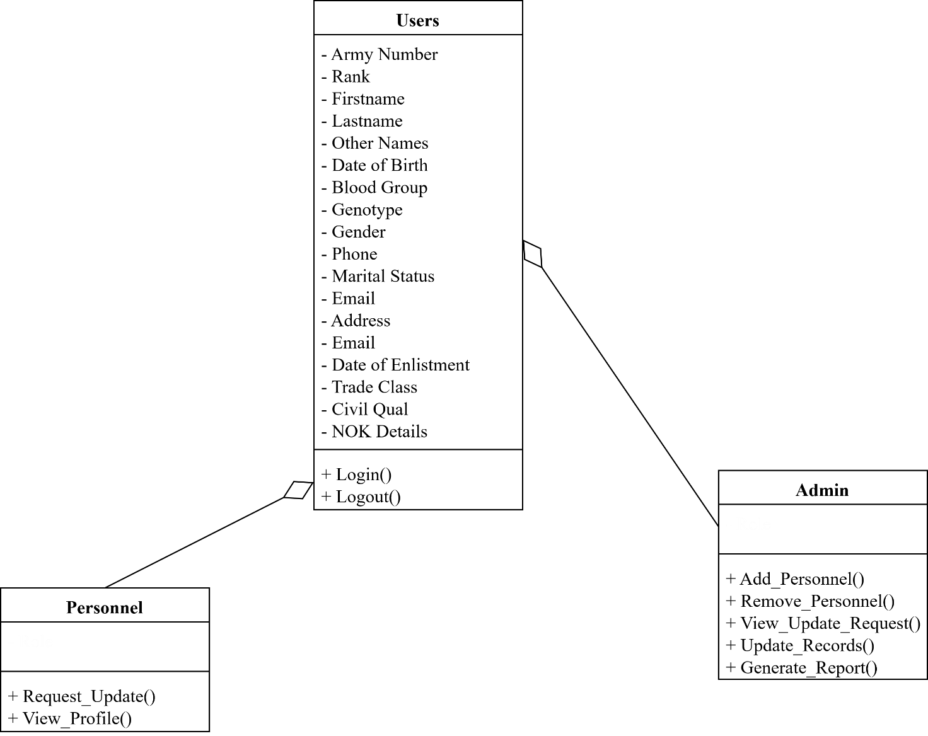

***Figure 4:*** *Class Diagram of the Proposed System*

**3.8.3 Activity Diagram**

Activity diagram is another important diagram in UML that is used to describe the dynamic aspects of a system. Activity diagram is basically a flowchart to represent the flow from one activity to another activity. The activity can be described as an operation of the system. The control flow of the proposed system is drawn from one operation to another and is better demonstrated in figure 3.5 below.

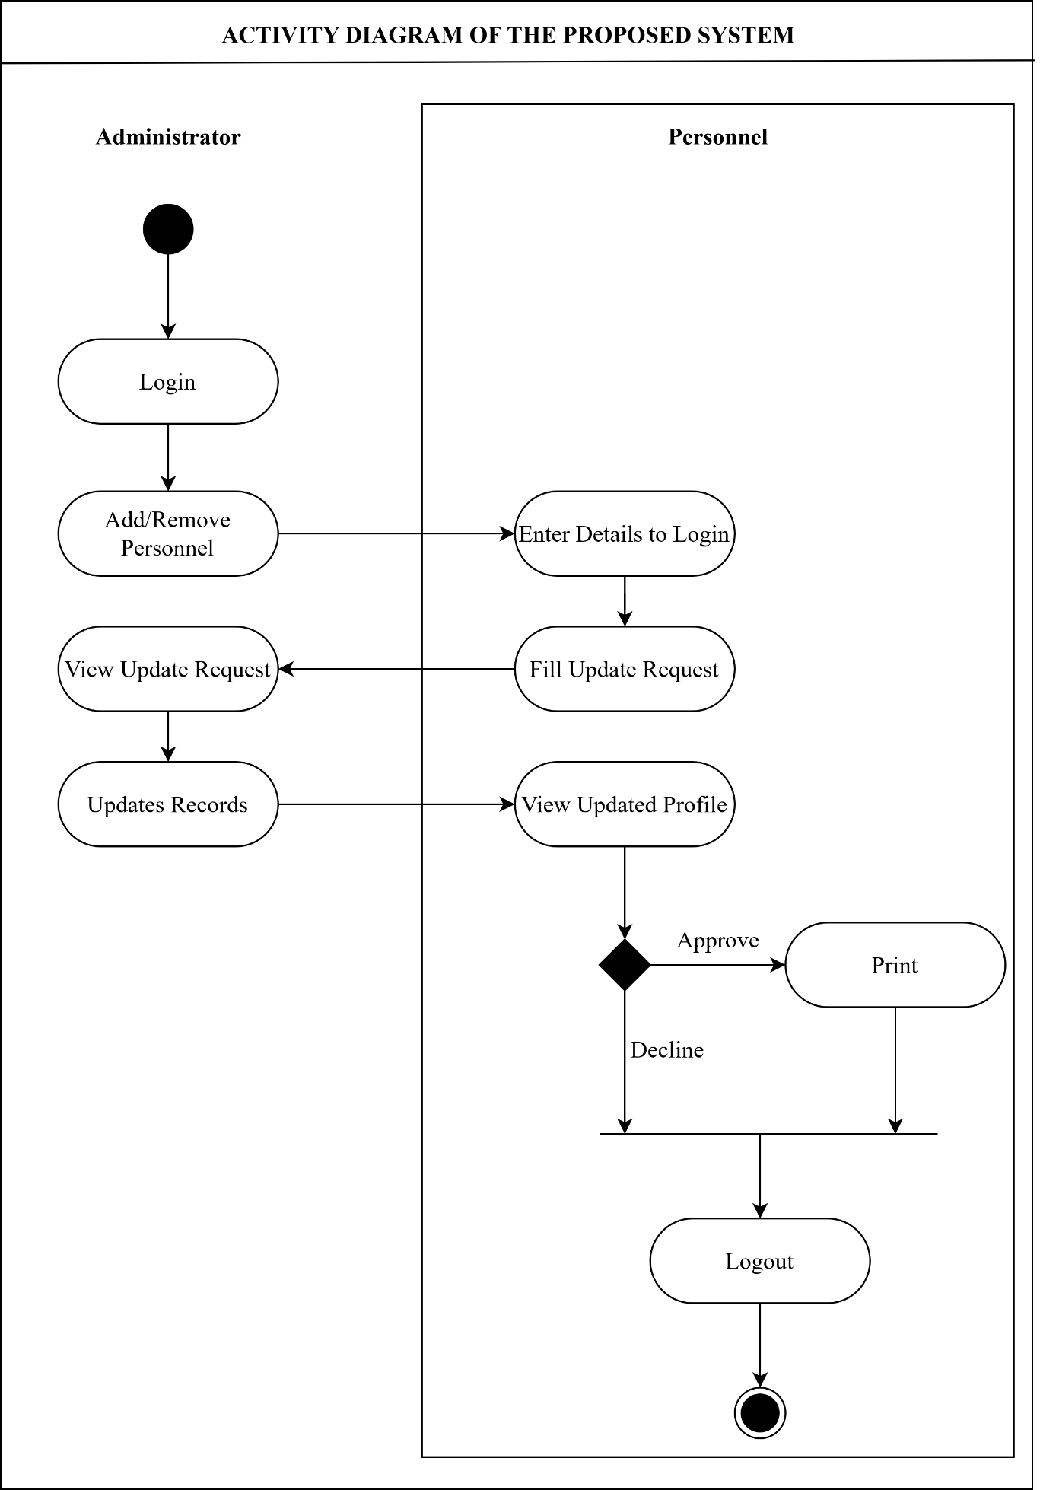

***Figure 5:*** *Activity Diagram of the Proposed System*

**CHAPTER FOUR**

**SYSTEM DESIGN AND IMPLEMENTATION**

**4.1 Objectives of the Design**

This project work was conducted with a view of designing a personnel information system for 23 Brigade Garrison of the Nigerian Army. When implemented the system will have the ability to:

1. Make use of MS Access, a popular desktop application which allows Unit clerks to register personnel and make updates to personnel information upon request by such personnel.
2. Provide remote access to information by personnel using a web platform and enable personnel self-service on individual records stored at the Unit Record Offices.
3. Make update request for personnel to facilitate amendment of information where necessary.
4. Reduce the time taken for retrieval and verification of personnel information at important periods like promotion.

**4.2 Decomposition and Cohesion of the High-Level Model**

To achieve the objectives of the developed system, several sub-elements were brought together to function as a single unit. The High-Level Model is an architectural explanation which provides an overview of the entire system. It identifies the main components that would be developed, users activities and various integrated interfaces. With the use of non-technical and largely mildly technical terms, this model should be understandable to the administrators of the system. The developed system is decomposed and explained in the following subheads.

**4.2.1 Control Center/Main Menu**

The system control center is a bi-platform by nature which focuses on the individual user roles that are in the developed system in which the functions of the system is initiated. They are:

1. Administrator: This is the only user of the MS Access application. The administrator can add/remove personnel and update information in the system. From the admin platform all administrative functions required on the system are carried out locally without recourse to the web interface.
2. Personnel: This is the only user of the web application. The personnel can view their profile maintained at their Unit record offices and request for update to where necessary.

**4.2.2 The Submenus/Subsystems**

Subsystem is a smaller method or procedure within a larger set of methods or procedures in a web application. They are other menu through which operations are performed. In the case of the developed system, the sub menus are broken down into admin sub-menu and user sub-menu:

1. Admin Sub-Menu: Through the MS Access application, the admin performs the functions to:

a. **Add/Remove User:** Users of the web platform are registered and removed from the system based on Unit manpower changes (posting).

b. **Update User Information:** Personnel information are updated based on requests by such personnel through the web application.

c. **Generate/View Report:** Unit report is generated.

1. **User Sub-Menu:** Through the web platform, personnel performs the following self-services:

a. **View Personal Profile:** The user who is logged-in to the system can view their personal information managed by the Unit.

b. **Request Update:** Information no more relevant are requested for update by the user through the request update submenu.

**4.3 System Specification**

System specifications help to define the operational and performance guidelines for a system. It may outline how the system is expected to perform, and what that may include. Key specifications may include interface definitions, document design rules and functional areas. The specifications of the new system are explained in the following subheads.

**4.3.1 Database Development Tool**

Database (DB) is a structured set of data held in a computer, especially one that is accessible in various ways. Database Management Systems (DBMS) are special software tools used to access and manipulate databases in computer systems. The DBMS tool used for the development of the new system is MySQL and MS Access DBMS.

**4.3.1.1 MySQL**

MySQL is an open source database that is platform independent and can easily interface with a number of scripting languages, it works best with PHP though. The number of advantages of using MySQL which include, the ability to handle stored procedures, triggers, Structured Query Language (SQL) and User Defined functions. It also offers a high-speed data load utility and support for various drivers (ODBC, JDBC, .NET, PHP).

Deploying a MySQL database has proved to be cheap and easy as it doesn’t require special hardware or software requirements, it can work well on any web server but most professionals recommend the apache web server. MySQL is an excellent database to use when developing web-based applications because its platform independent and can easily interface with a number of scripting languages.

**4.3.1.2 Microsoft Access**

Microsoft Access is a DBMS from Microsoft that combines the relational Microsoft Jet Database Engine with a graphical user interface and software development tools.  A common use of Microsoft Access is to keep it as a front end to more commercially successful DBMSs. In this project, the ODBC driver of Access is used to establish a high-speed data load support to a MySQL database, so the application written in Access connects through to data held in a MySQL database.

**4.3.2 Database Design and Structure**

Files held in this project are made up of different data types. These types are integer, character, date etc. some of the files used are designed and linked with database. Also in the project design, MySQL and Microsoft access databases were used. Below is the database specification for the files used.

|  |  |  |
| --- | --- | --- |
| **Field Name** | **Data Type** | **Size** |
| army_number | VARCHAR | 15 |
| phone | VARCHAR | 11 |

***Table 4.1*** *Login Table*

**4.3.3 Input Format**

The input design facilitates the entry data into the computer system. This entails that the selection of the best strategy for getting data into the computer system at the right time and as accurately as possible. The use of well-defined interface encourages users to input data accurately without omission. Input design must capture all the data that the system needs without introducing errors.

The input form is the format of data that is inputted into the developed system. In the developed system, text is inputted into the system. The format is text.

**LOGIN**

Username:

Login

Password:

Fig 4.1 Admin Login Module

***Figure 4:*** *Personnel Login Module*

As shown in fig 4.1 and 4.2, the login module allows admin/users of the systems to login into the various system by supplying their username and password for authentication.

**4.3.4 Output Format**

The output design allows the system to indicate the effect of the users’ manipulation. The output format for the developed system is in text form. (See appendix A).

**4.3.5 Data Dictionary**

A Data Dictionary is a collection of names, definitions, and attributes about data elements that are being used or captured in a database, information system, or part of a research project. It describes the meanings and purposes of data elements within the context of a project, and provides guidance on interpretation, accepted meanings and representation. A Data Dictionary also provides metadata about data elements. The metadata included in a Data Dictionary can assist in defining the scope and characteristics of data elements, as well the rules for their usage and application.

|  |  |  |
| --- | --- | --- |
| **Column** | **Data Type** | **Description** |
| Serial | int(11) | This is the sequential arrangement of the records in the database |
| Army_number | varchar(15) | Army number for each personnel which uniquely identifies personnel and is used as the login detail |
| Rank | varchar(10) | Personnel current rank |
| Surname | varchar(20) | Surname for personnel |
| Firstname | varchar(20) | Firstname for personnel |
| Other_names | varchar(15) | Personnel other names (optional) |
| dob | date(10) | Personnel date of birth |
| Sex | varchar(8) | Personnel gender |
| marital_status | varchar(8) | Personnel marital status |
| phone | varchar(11) | Personnel contact number which serves as login password |
| address | varchar(100) | Personnel contact address at the Unit |
| trade_class | varchar(15) | Last course attended by personnel and its classification |
| civil_qual | varchar(30) | Highest civil qualification of personnel |
| Blood_gp | varchar(4) | Personnel blood group |
| genotype | varchar(4) | Personnel genotype |
| email | varchar(30) | Personnel email address |
| Dolp | date(10) | Personnel date of last promotion |
| doe | date(10) | Personnel date of enlistment (date began training upon admittance into the NA) |
| NOK_details | varchar(100) | Next of Kin name, contact address, phone number and relationship with personnel |

***Table 4.2:*** *Data Dictionary of the System*

**4.4 System Implementation**

This section shows the actual running of the system. Here the development tools are analyzed and the system requirements are made known. Proper tests are also made to ascertain if the developed system conformed with the intended objectives.

**4.4.1 Proposed System Requirements**

This consists of the requirement that must be met by the target system to enable a software that has been developed to function efficiently. Hence, configuration specifications of the target system must be compatible with the software, target computer system requirements will be discussed in the software and hardware requirements.

**4.4.1.1 Hardware Requirement**

These are the physical machines or equipment which can be seen, touched and felt and are involved in the system, and the appropriate computer. The hardware requirements for the proposed system is contained in table 4.3.

|  |  |  |
| --- | --- | --- |
| **S/N** | **Component** | **Requirement** |
| 1 | RAM | 512MB or higher |
| 2 | Hard Disk | 10GB or higher |
| 3 | Processor | 333MHZ or higher |

­­­­***Table 4.3:*** *Hardware Requirements for the Target Computer System*

**4.4.1.2 Software Requirement**

Software is a collection of instructions and data that tell a computer how to work. The software requirements for the proposed system is contained in table 4.4

|  |  |  |
| --- | --- | --- |
| **S/N** | **Component** | **Requirement** |
| 1 | Operating System | Windows 7 or later versions |
| 2 | Memory | 128MB or higher |
| 3 | Local Host Server | XAMPP Control Panel (Version 3.2.2) |
| 4 | Microsoft Access | Office 2007 or later versions |

**Table 4:** Software Requirements for the Target Computer System

**4.4.2 Program Development**

Program Development is the process of conceiving, specifying, designing, programming, documenting, testing, and bug fixing involved in creating and maintaining applications, frameworks, or other software components.

**4.4.2.1 Choice of Programming Language**

The programming language used in the implementation of this project are PHP (Hypertext Preprocessor) programming language, Visual Basic for Applications (VBA) and MySQL. PHP is general purpose server-side scripting language originally designed for web development to produce dynamic web pages. It has also evolved to include a command line capability and can be used in stand-alone graphical applications. The VBA is an event-driven programming language from Microsoft. It is now predominantly used with Microsoft Office applications such as MSExcel, MS-Word and MS-Access. It is applied in this system to create a login form for the admin inside the MS Access Application.

**4.4.3 System Testing**

This section of the implementation involves the testing and debugging of the program. A primary purpose of testing is to detect software failures so that defects may be discovered and corrected. Testing cannot establish that a product functions properly under all conditions, but can only establish that it does not function properly under specific conditions. The scope of software testing often includes examination of codes as well as examining the aspect of code that determines if the software does what it is supposed to do and what it needs to do.

The system strategies explored in this research are desk, unit and integration testing. Others are alpha and beta testing which are discussed below.

**4.4.3.1 Desk Testing**

A desk check is an informal non-computerized or manual process for verifying the programming and logic of an algorithm before the program is launched. A desk check helps programmers to find bugs and errors which would prevent the application from functioning properly. After the development of the system, it was checked by running it as a whole and going through all processes that users may be required to access.

**4.4.3.2 Unit Testing**

The primary goal of unit testing is to take the smallest piece of testable software in the application, isolate it from the remainders of the code and determine whether it behaves exactly as it is expected. Each unit is tested separately before integrating them into modules to test the interfaces between modules. Unit testing has proven its value in that a large percentage of its defects are identified during its use. The most common approach to unit testing requires drivers and subs to be written. A driver stimulates a calling unit and the subs simulate a called unit. This approach allows for automation of the testing process, reduces difficulties of discovering errors contained in more complex pieces of the application and test coverage is then enhanced because attention is given to each unit. During the unit testing, carried out by the researcher, some errors were raised and all of them were rectified with satisfactory result.

**4.4.3.3 Integration Testing**

Integration testing is a logical extension of unit testing. In a simplest form, two units that already been tested are combined into a component and the interface between them is tested. A component in this sense refers to an integrated aggregate of more than one unit. In a realistic scenario, many units are combined into the components which are in turn aggregated into larger parts of the system. The idea is to test combination of pieces and eventually expand the process to test the modules with those of other groups. There are generally three methods of integration testing. These are the top-down approach, the bottom-up approach and the umbrella approach. In this research, the bottom-up approach was used. This requires the testing and integration of lower-level units first. By using this approach, utility modules are tested early in the development process and the needs for stubs are minimized. Results from the integration test of the research were satisfactory.

**4.4.3.4 Alpha Testing**

Alpha testing is the first end-to-end testing of a product to ensure it meets the business requirements and functions correctly. The alpha testing proceeds until the system developer and the customer agree that the provided system is an acceptable implementation of the system requirements. The developed system was tested by the development team in order to ensure it meets the set objectives.

**4.4.3.5 Beta Testing**

During beta testing, a system is delivered among a number of potential users who agree to use it. The customers then report problems to the developers. This provides the product for real use and detects errors which may not have been anticipated by the system developers.

Modifications can be made at the system testing stage in the design specification. Changes made at this point would be less costly when compared to the making of such changes when the system is fully operational. The summary of result generated at the various testing stages of the software are summarised in table 4.5.

|  |  |  |  |  |  |
| --- | --- | --- | --- | --- | --- |
| **Test No** | **Field Name** | **Type** | **Description** | **Outcome** | **Reference (Appendix B)** |
| Test 1 | Login | MS Access Form | User Authentication | Grants access to users | Figure 1.1 & 1.2 |
| Test 2 | Register User | MS Access Form | Creates a new user | A user is created | Figure 5 |
| Test 3 | View update request | MS Access Report | Admin views all update requests from user | Views all update requests | Figure 3 |
| Test 4 | Report | MS Access Report | Admin views a created report on all personnel registered | Views personnel report | Figure 3.2 & 6 |
| Test 5 | Profile | Web application | Enables Personnel view their profile | Displays personnel profile for all individual | Figure 2 |
| Test 6 | Request update | Web application | Enables user to request for updates | User submits update request | Figure 3.1 |
| Test 7 | Logout | Web application | Terminates all sessions | Exits the user from the page | Active on all User Pages |

***Table 4.5:*** *System Testing*

**4.4.5 System Security**

Any system developed should be secured and protected against possible hazards. Security measures are provided to prevent unauthorized access of the database at various levels. An uninterrupted power supply should be so that the power failure or voltage fluctuations will not erase the data in the files. Password protection and simple procedures to prevent any unauthorised access are provided to the users. The system allows the user to enter the system only through proper username and password.

**4.4.6 Training**

After the system is implemented successfully, training of the admin is one of the most important subtasks of the developer. The user only requires skill on use of a web page and might not require any special training to use the online platform. For the purpose of admin that changes periodically, user manuals and tutorial videos are prepared and handed over to the Unit to operate the developed system. Thus, the users are trained to operate the developed system. Both the hardware and software securities are made to run the developed systems successfully in future. In order to put new application system into use, the following activities were taken care of:

1. Preparation of user guide and system documentation.
2. Conducting unit training for clerical staffs with hands on demonstrations.
3. Test run for a certain period to ensure proper workability of the system for a smooth switch over of the system.

The users are trained to use the newly developed functions of the system. User manuals describing the procedures for using the functions listed on menu are circulated to all the users. It is confirmed that the system is implemented up to users need and expectations.

**4.4.7 System Conversion**

The system conversion is concerned with smooth shift from one way of doing a thing to another. It is the mitigation or destruction of business activities during the change over. This system however is open to any of the changeover method below:

**4.4.7.1 Pilot Conversion**

The pilot system changeover is the situation of using a small unit of an organisation as a sample and case study for experimental purpose. This sample unit is called the pilot. It is not directly used in the entire system but only experimental in a module before the application is carried out and introduced to the entire system if proved successful. Pilot module assures the efficient working of new system and reduces the risk of total system failure. This is alsoless expensive than the parallel operation as only at one section both system works for limited period.

**4.4.7.2 Phased Conversion**

A phased conversion method is a situation whereby one part of the overall system that needs change is changed. This method is limited in scope and therefore not critical. Once a system has been successfully changed in one area, the other area follow suit with lessons learnt during the initial changeover use to ensure the success of the conversion as a whole.

**4.4.7.3 Parallel Conversion**

In this case, both the old and the new systems run side by side using life data. So that the project manager can compare the efficiency and reliability of the new system. Once they are satisfied, the old system is taken offline and the new system become fully active and utilized across the organisation.

**4.4.7.4 Direct Conversion**

In direct conversion, there is a single fix point where one system stops from being used and the new one become alive. This is the cheapest ad quickest, easy form of system changeover but it is the most risky. If the system is broken off inefficient, the whole system suffers. This is the preferred conversion method for the developed system as it reduces cost and there is zero risk in a case of system failure. Due to the system use of dual DBMS, the data stored in the system remains intact in the case of a web failure as there is 100% data integrity between the platforms. In the case of system crash, either of the platforms serves as a recovery channel.

**CHAPTER FIVE**

**SUMMARY, CONCLUSION AND RECOMMENDATION**

5.1 Summary

In this project work, an insight on how personnel roles and functions are administered in an organisation like 23 Brigade Garrison of the Nigerian Army is presented. However, various difficulties confronting an organisation were identified in realizing its target, aims or objectives as well as making suggestions and recommendations to the management in order to improve it system generally.

Once again, the concept of personnel management was examined and it is felt that it would be of useful purpose to the readers, students of management, managers of companies as well as administrative practitioners. Hence, personnel information system software was development to assist clerical staffs at Unit level keep track of personnel record.

5.2 Conclusion

The role of personnel information has become an integral part of an establishment set up in Nigerian society. The results of this study coupled with the relative observation in similar organizations in this country have shown an indication that personnel management, as oxygen is to human lungs, is a function that cannot be under-estimated and over rolled in any organization where efficiency of operation is a matter of consideration. The workforce or manpower resource of an organization is the most valuable asset and as such, this aspect of managerial role requires urgent and special attention.

By implementing the computerized staff management system will help the organizations to plan their human resources both quantitatively and qualitatively. Being an information system of human resources, it can store voluminous data about the staffs; and assists not only in identifying the occupied and unoccupied position, but also whether the person is fit for a particular task or not. Other conclusions that can be drawn from the implementation of the staff information system include a healthier human resources decisions, enhanced supervision and control of manpower. Also, the system being an automated one aids in reducing various costs such as labour and recruitment cost; and exert outstanding strategic activities such as training and development, succession planning, tracking of applicant recruitment and selection, manpower planning, staff information, attendance tracking, salary planning, absenteeism analysis and work scheduling. At this juncture, it can be accomplished that staff information system is an excellent tool for human resources management as it facilitates in generating primary reports, and important information could be stored and updated automatically.

5.3 Recommendations

The Personnel Information System (PIS) is recommended for use in the Nigeria Army as Units can be assured of reliability and security of staff information. Also, the developed system can be packaged and improved upon to become a generic one that can be deployed to the Army Headquarters for use by all formations, training institutions, schools etc. To achieve this there will be need to carry out activities such as data test, user acceptance testing, system review and deployment. Albeit, there are some areas that needs further improvement for future researchers. Some of these areas are; since there are always changes and growth in requirements and these would automatically affect every software project, so there is need to timely update them, updating of assets and liabilities, certifications, organizational and staffing pattern. The documentation processes in this study are also good source of information for further database system development and data analysis for academic work.

Other recommendations to be taken into consideration include:

Firstly, if people consider the various problems of personnel management the wastages of organization human and material resources should be kept to a practical minimum level. This is because we cannot do without personnel management in any organization. Hence the need for the implementation of this personnel management information software developed in this project work.

Secondly, it is clear that there are many people who have inborn capabilities for management. This is a natural trait, which could be better off if the government can improve the appropriate training and techniques for proper utilization of these traits to accomplish the original objectives.

Thirdly, the personnel department should be competent to advice on the best and most modern techniques, technologies and practices to provide a professional support and monitoring services in the area of this study.

Lastly, Workers should be given their rights and there should be the establishment of mutual co-operation between the employer and the employees with view of eradicating conflicts problems of fatigue, lay-off and improving the industrial harmony within the organization.

Furthermore, the individual needs which become paramount for his joining the organization, should always be given priority attention. This will not only motivate him and increase his productivity but will also give him brighter chances of better career prospects in the enterprise and at the same time, self-actualize himself.

This package could be redesigned to include payroll system of the organisation so that the co-ordination between the Admin and Supply department and the Finance and Account department should be enhanced. Additionally, the system could be improved upon to prevent removal of posted out personnel. Creation of an isolated database to hold record of posted out personnel from the Unit could suffice.

**REFERENCE**

Arden A. (2017). The Impact of GDPR on HR and Personal Data.

Published at https://www.hrsolutions-uk.com/impact-gdpr-hr-personal-data.

Armstrong, M., & Taylor, S. (2014). Armstrong's handbook of Human Resource Management Practice.

Kogan Page Publishers.

Arur, G., Nair P. S. & Mathur, S. (2021). Oracle Human Resources Management Systems Enterprise and Workforce Management Guide, Release 12.1 Part No. E13511-19, Oracle and/or its affiliates.

Bal, Y., Bozkurt, S. and Ertemsir, E. (2012) The Importance of Using Human Resources Information Systems (HRIS) and a Research on Determining the Success of HRIS. Knowledge and Learning: Global Empowerment. Proceedings of the Management, Knowledge and Learning International Conference 2012, International School for Social and Business Studies, Celje, 20-22 June 2012, 53-62.

Bulmash, J., (2013). Human Resources Management and Technology. Human Resources Management in Canada.

Boateng A, (2017). The Role of Human Resource Information Systems (HRIS) in Strategic Human Resource Management (SHRM) [Thesis].

Published at Swedish School of Economics and Business Administration.

Sweden.

Bondarouk, T., Parry, E. & Furtmueller, E. (2017). Electronic HRM: Four Decades of Research on Adoption and Consequences, The International Journal of Human Resource Management.

Bondarouk, T. & Ruël, H. (2013). The strategic value of e-HRM: Results from an Exploratory Study in a Governmental Organization. The International Journal of Human Resource Management.

CIPD (2018). Data Protection. [Online] URL: https://www.cipd.co.uk/knowledge/fundamentals/emp-law/data-protection, 2018

Hassan, S. (2016). Impact of HRM on Employee’s Performance. International Journal of Academic Research in Accounting, Finance and Management Sciences, 6, 15-22. https://doi.org/10.6007/IJARAFMS/v6-i1/1951.

Johnson, R. D., Lukaszewski, K. M., & Stone, D. L. (2016). The Evolution of the Field of Human Resource Information Systems: Co-Evolution of Technology and HR Processes. Communications of the Association for Information Systems.

Kavanagh, M. J., Thite, M., & Johnson, R. D. (Eds.). (2015). Human Resource Information Systems (3rd ed.). Thousand Oaks, CA: Sage.

Kaur, P. (2013). E-HRM: A Boon or Bane? Anveshanam. A National Journal of Management.

Marlene, S. A., Silver, E. & Guilherme da Silva Lima, C. (2017). The Role of Information Systems in Human Resource Management. Submitted: May 18, 2017, reviewed: June 4, 2018.

Published Dec 21, 2017. DOI: 10.5772/intechopen.79294

Marler, J., & Fisher, S. (2013). An Evidence-Based Review of e-HRM and Strategic Human Resource Management. Human Resource Management.

Marler, J. H., & Parry, E. (2015). Human Resource Management, Strategic Involvement and e-HRM technology. The International Journal of Human Resource Management.

Nabi, Md. N., Syduzaman, Md., & Munir, Md. S. (2016). The Impact of Human Resource Management Practices on Job Performances: A Case Study of Dhaka Bank Pvt. Ltd., Bangladesh. Human Resource Management Research, 6, 45-54.

Nenwani, P. J., & Raj, M. D. (2013). E-HRM Prospective in Present Scenario. International Journal of Advance Research in Computer Science and Management Studies.

Nivlouei, F. B. (2014). Electronic Human Resource Management System: The Main Element in Capacitating Globalization Paradigm. International Journal of Business and Social Science.

Parul, M., Parab, N., Sankpal, M., Morde, C. (2013). Personal Information System. International Journal of Scientific & Engineering Research, Volume 4.

Ravitch, S. M. & Riggan, M. (2017). How Conceptual Frameworks Guide Research. 2nd Edn.

Los Angeles, CA: Sage.

Ruël, H., & Kaap, Van Der H. (2012). E-HRM Usage and Value Creation. Does a Facilitating Context Matter? German Journal of Research in Human Resource Management.

Ruël, H., & T. Bondarouk. (2014). E-HRM Research and Practice: Facing the Challenges Ahead. In Handbook of Strategic e-Business Management. Springer Berlin Heidelberg.

Stone. D. L., Deadrick, D. L., Lukaszewski, K. M., & Johnson, R. (2015). The Influence of Information Technology on the Future of Human Resource Management. Human Resource Management Review.

Swanson, R. A. (2013). Theory Building in Applied Disciplines.

San Francisco, CA: Berrett-Koehler.

Van Geffen, C., Ruël, H. J. M., & Bondarouk, T. (2013). e-HRM in MNCs: What can be Learned from a Review of the IS Literature? European Journal of International Management.

Wallen J. (2013). Four Open-Source SMB-Centric Human Resource Management Systems.

Wilkerson A. (2015). Draft – The Impact of Information Technology on HRM [Internet]. Available from:https://www.academia.edu/8301970/Draft_The_Impact_of_Information_Technology_on_HRM.

**APPENDIX A**

**PROGRAM SOURCE CODE**

**User Login**

<?php

  session_start();

  include_once 'connections/dbh.inc.php';

  if(isset($_POST['login'])){

    $username = $_POST['armyNo'];

    $password = $_POST['phone'];

$query = mysqli_query($conn, "select * from personnel_details1 where phone='$password' and army_no='$username';");

    $result_count = mysqli_num_rows($query);

    if($result_count > 0 ){

        $users = mysqli_fetch_array($query);

        $role = $users['role'];

        $name = $users['lastname'];

        $_SESSION['uid'] = $username;

        $_SESSION['role'] = $role;

        $_SESSION['fname'] = $name;

      if($role == "admin"){

          header("location: admin_dashboard.php");

        }else{

          header("location:user_profile.php");

        }

    }else{

        echo "<script>alert('Incorrect username and password!');</script>";

    }

  }

?>

<!DOCTYPE html>

<html lang="zxx">

<head>

  <title>PIS || Login</title>

  <!-- Meta tag Keywords -->

  <meta name="viewport" content="width=device-width, initial-scale=1">

  <meta charset="UTF-8" />

  <!-- //Meta tag Keywords -->

  <link href="//fonts.googleapis.com/css2?family=Kumbh+Sans:wght@300;400;700&display=swap" rel="stylesheet">

  <!--/Style-CSS -->

  <link rel="stylesheet" href="css/style2.css" type="text/css" media="all" />

  <!--//Style-CSS -->

  <link rel="stylesheet" href="css/font-awesome2.min.css" type="text/css" media="all">

</head>

<body>

  <div class="w3l-signinform">

    <!-- container -->

    <div class="wrapper">

      <!-- main content -->

      <div class="w3l-form-info">

        <div class="w3_info">

          <h1>23 Brigade Garrison</h1>

          </h1>

          <p class="sub-para">Personnel Information System</p>

          <h2>Log In</h2>

          <form action="" method="post">

            <div class="input-group">

              <span><i class="fa fa-user" aria-hidden="true"></i></span>

           <input type="text" placeholder="Army Number" name="armyNo" required="">

            </div>

            <div class="input-group two-groop">

              <span><i class="fa fa-key" aria-hidden="true"></i></span>

              <input type="text" placeholder="Phone" name="phone" required="">

            </div>

            <div class="form-row bottom">

              <div class="form-check">

            <input type="checkbox" id="remenber" name="remenber" value="remenber">

                <label for="remenber"> Remember me?</label>

              </div>

              <!-- <a href="#url" class="forgot">Forgot password?</a> -->

            </div>

            <button class="btn btn-primary btn-block" type="submit" name="login">Log In</button>

          </form>

      <p class="account">Unable to login? Contact 23 Bde Gar CC on 07062335430 </p>

        </div>

      </div>

      <!-- //main content -->

    </div>

    <!-- //container -->

    <!-- footer -->

    <div class="footer">

      <p>&copy; Department of Computer Science - NACEST 2021. All Rights Reserved | Design by <a href="#">D'Eagle</a>

      </p>

    </div>

    <!-- footer -->

  </div>

</body>

</html>

**User Profile**

<?php

  include_once 'include/header.php';

  include_once 'include/aside.php';

  include_once 'connections/dbh.inc.php';

?>

<!--sidebar end-->

<!--main content start-->

<section id="main-content">

  <section class="wrapper">

    <div class="table-agile-info">

      <div class="panel panel-default">

        <div class="panel-heading">

          User Profile for <?php echo $_SESSION['uid'] ; ?>

        </div>

        <div>

          <table class="table" ui-jq="footable" ui-options='{

        "paging": {

          "enabled": true

        },

        "filtering": {

          "enabled": true

        },

        "sorting": {

          "enabled": true

        }}'>

            <tbody>

              <?php

            $username = $_SESSION['uid'];

            $sql = "SELECT * FROM personnel_details1 WHERE army_no = '$username';";

              $result = mysqli_query($conn, $sql) or die(mysqli_error($conn));

              $row=mysqli_fetch_array($result);

              $id=$row['army_no'];

              ?>

              <tr data-expanded="true">

                <td>Army Number: <?php echo $row['army_no']; ?></td>

                <td>Rank: <?php echo $row['rank']; ?></td>

                <td>Firstname: <?php echo $row['firstname'] ?></td>

                <td>Surname: <?php echo $row['surname']; ?></td>

                <td>Other Names: <?php echo $row['other_names']; ?></td>

                <td>

              </tr>

              <tr data-expanded="true">

                <td>DOLP: <?php echo $row['dolp']; ?></td>

                <td>NOK: <?php echo $row['NOD_details']; ?></td>

                <td>Phone: <?php echo $row['phone']; ?></td>

                <td>Email: <?php echo $row['email']; ?></td>

                <td>Address: <?php echo $row['address'];  ?></td>

                <td>

              </tr>

              <tr data-expanded="true">

                <td>Blood Group: <?php echo $row['Blood_gp']; ?></td>

                <td>Genotype: <?php echo $row['genotype'];; ?></td>

                <td>Marital Status: <?php echo $row['marital_status']; ?></td>

                <td>Trade Class: <?php echo $row['trade_class']; ?></td>

                <td>Civil Qual: <?php echo $row['civil_qual']; ?></td>

                <td>

              </tr>

              <tr data-expanded="true">

                <td>Date of Birth: <?php echo $row['dob']; ?></td>

                <td>Gender: <?php echo $row['sex']; ?></td>

                <td>DOE: <?php echo $row['doe']; ?></td>

                <td>

              </tr>

              <?php

             // }

              ?>

            </tbody>

          </table>

        </div>

      </div>

    </div>

  </section>

  <!-- footer -->

  <?php

  include_once 'include/footer.php';

?>

  <!-- / footer -->

</section>

<!--main content end-->

</section>

<script src="js/bootstrap.js"></script>

<script src="js/jquery.dcjqaccordion.2.7.js"></script>

<script src="js/scripts.js"></script>

<script src="js/jquery.slimscroll.js"></script>

<script src="js/jquery.nicescroll.js"></script>

<script src="js/jquery.scrollTo.js"></script>

</body>

</html>

**User Request Update**

<?php

  include_once 'include/header.php';

  include_once 'include/aside.php';

  include_once 'connections/dbh.inc.php';

  if(isset($_POST['submit'])){

    $update_requested = isset($_POST['make_req'])?$_POST['make_req']:"";

    $army_no = $_SESSION['uid'];

    $sql = "INSERT INTO update_requests (army_number, updates) VALUES ('$army_no','$update_requested');";

  if (mysqli_query($conn, $sql)){

          echo "<script>alert('Update Request Submitted Successfully'); window.location.href='user_profile.php';</script>";

    }else{

      echo "<script>alert('Click the submit button to request update');</script>";

      }

  }else{

    echo "Update request not submitted". mysqli_error($conn);

  }

?>

<!--main content start-->

<section id="main-content">

  <section class="wrapper">

    <div class="form-w3layouts">

      <!-- page start-->

      <!-- page start-->

      <div class="row">

        <div class="col-lg-12">

          <section class="panel">

            <header class="panel-heading">

              Welcome <?php echo $_SESSION['uid']; ?>

            </header>

            <div class="panel-body">

              <div class="position-center">

                <form role="form" action="" method="POST">

                  <div class="form-group">

              <label for="suggest">Enter Requested Updates (Detail - value)</label>

    <textarea rows="4" cols="50" class="form-control" id="suggest" name="make_req"

                      placeholder="Enter Update Requests" required></textarea>

                  </div>

                  <div class="checkbox">

                    <label>

                      <!-- <input type="checkbox"> Done -->

                    </label>

                  </div>

          <button type="submit" class="btn btn-info" name="submit">Submit</button>

                </form>

              </div>

            </div>

          </section>

          <!-- footer -->

          <?php

  include_once 'include/footer.php';

?>

          <!-- / footer -->

  </section>

  <!--main content end-->

</section>

<script src="js/bootstrap.js"></script>

<script src="js/jquery.dcjqaccordion.2.7.js"></script>

<script src="js/scripts.js"></script>

<script src="js/jquery.slimscroll.js"></script>

<script src="js/jquery.nicescroll.js"></script>

<script src="js/jquery.scrollTo.js"></script>

</body>

</html>

**APPENDIX B**

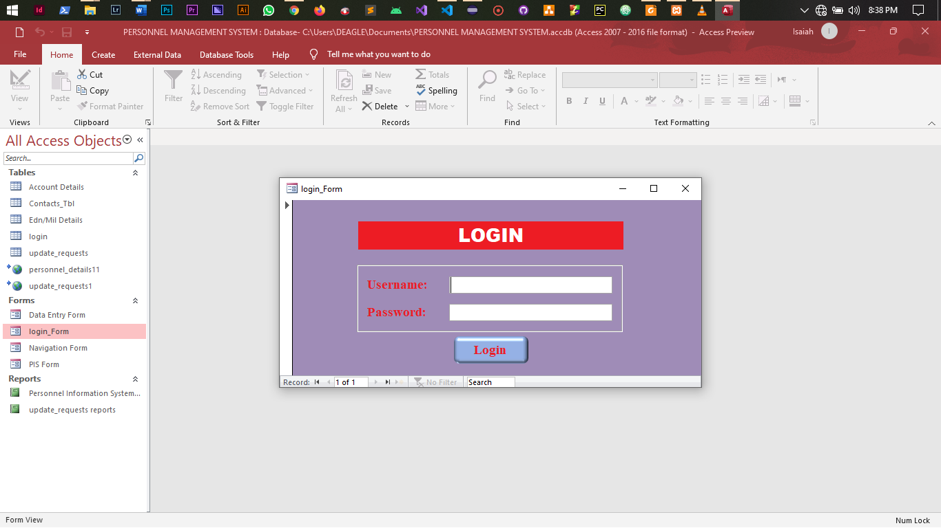**SCREENSHOTS**

**Figure 1.1:** Admin Login page

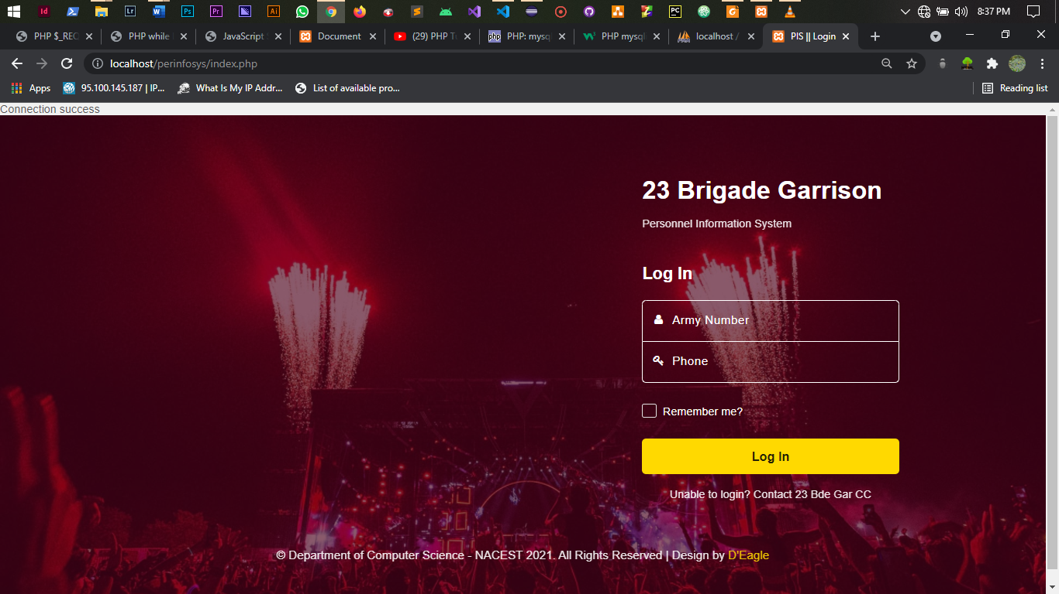

**Figure 1.2:** User Login Page

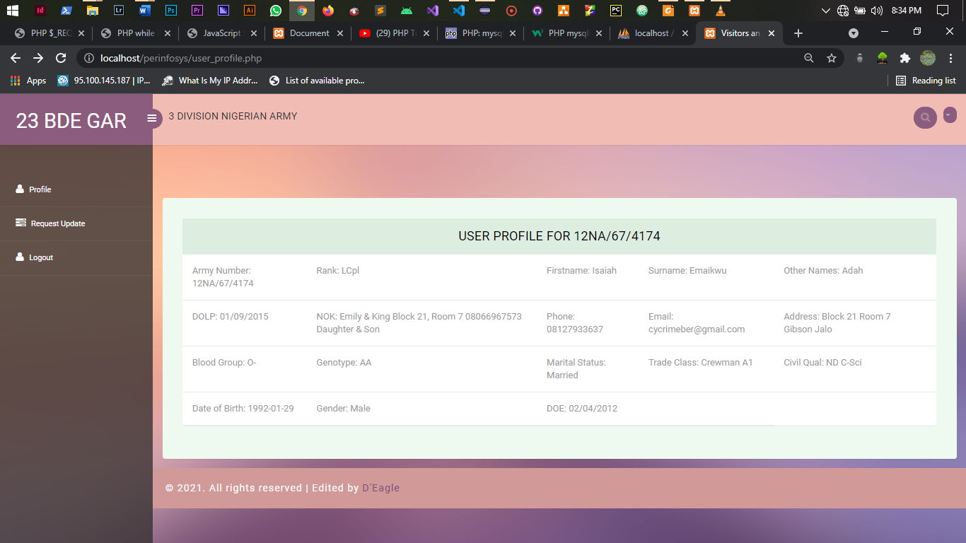

**Figure 2:** User Profile Page

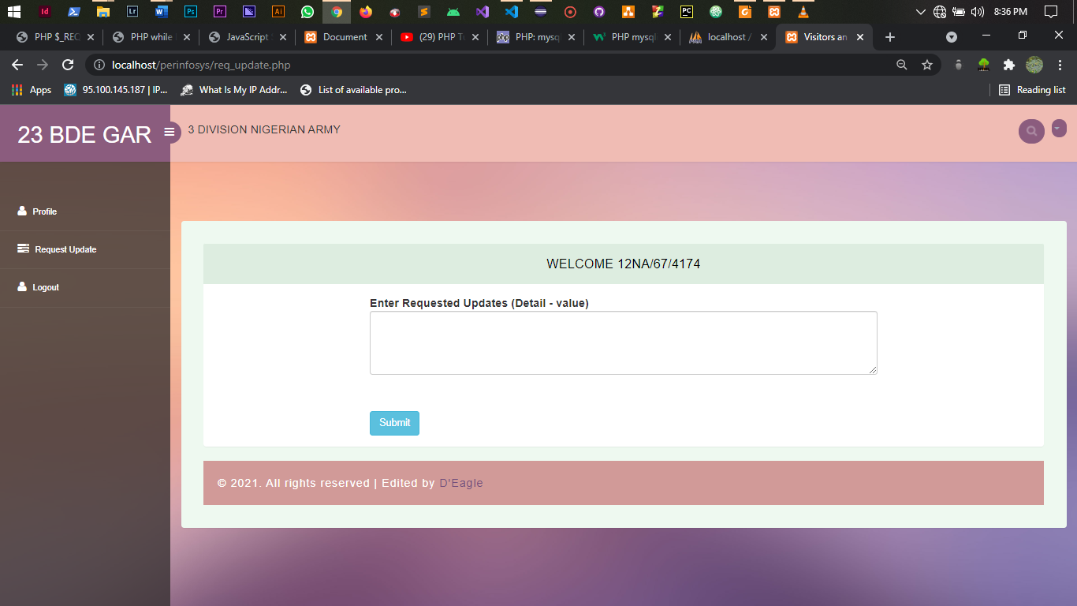

**Figure 3.1:** User Update Request Page

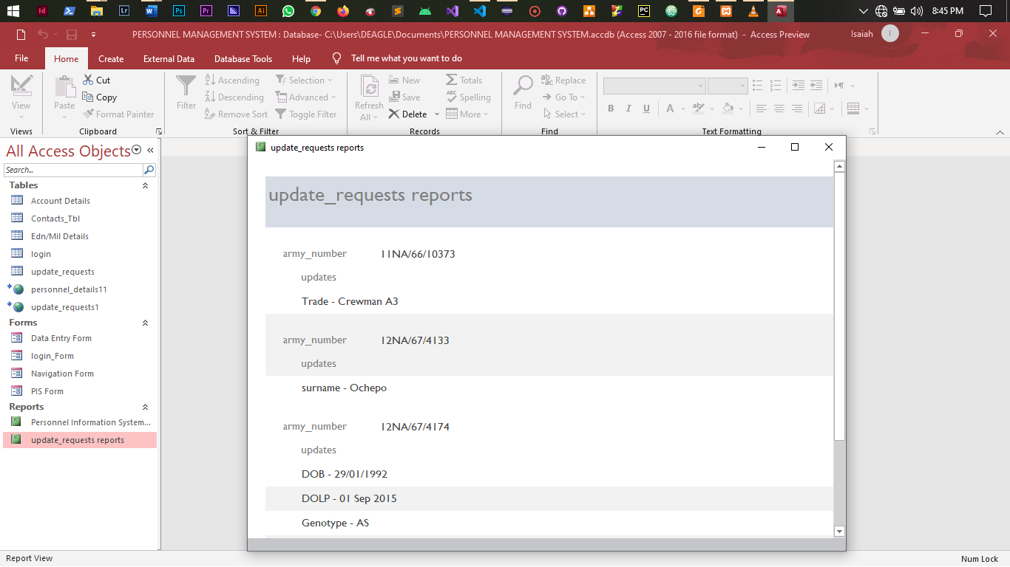

**Figure 3.2:** Admin Update Request Report

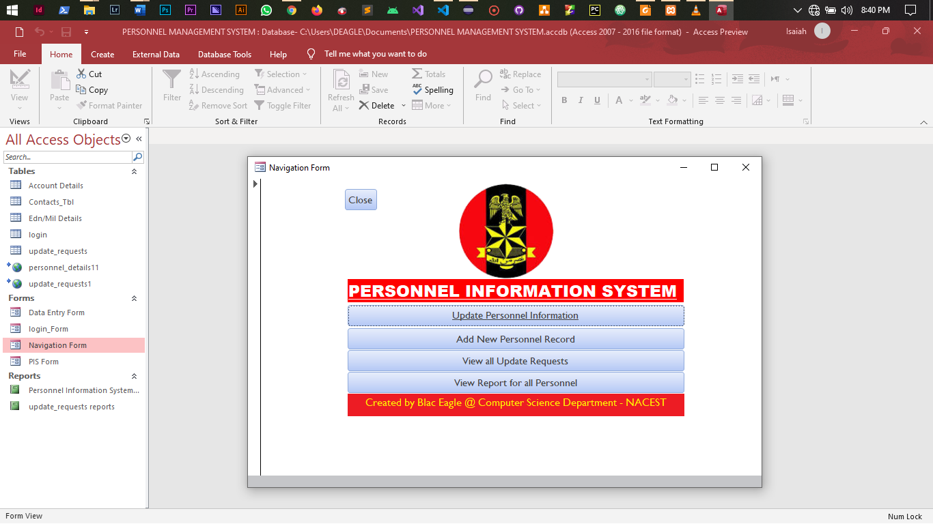

**Figure 4:** Admin Navigation Form

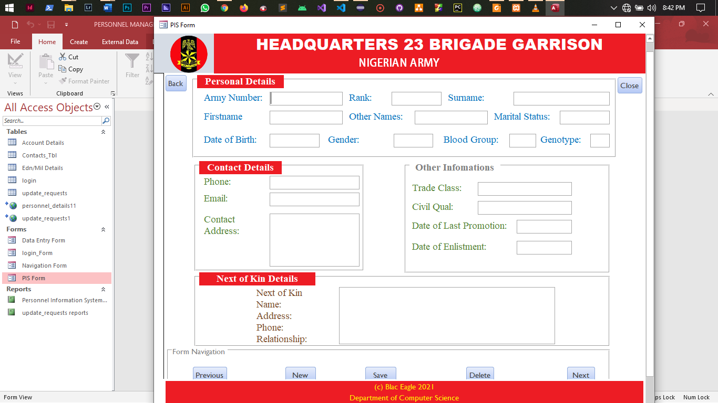

**Figure 5:** Admin Data Entry Form

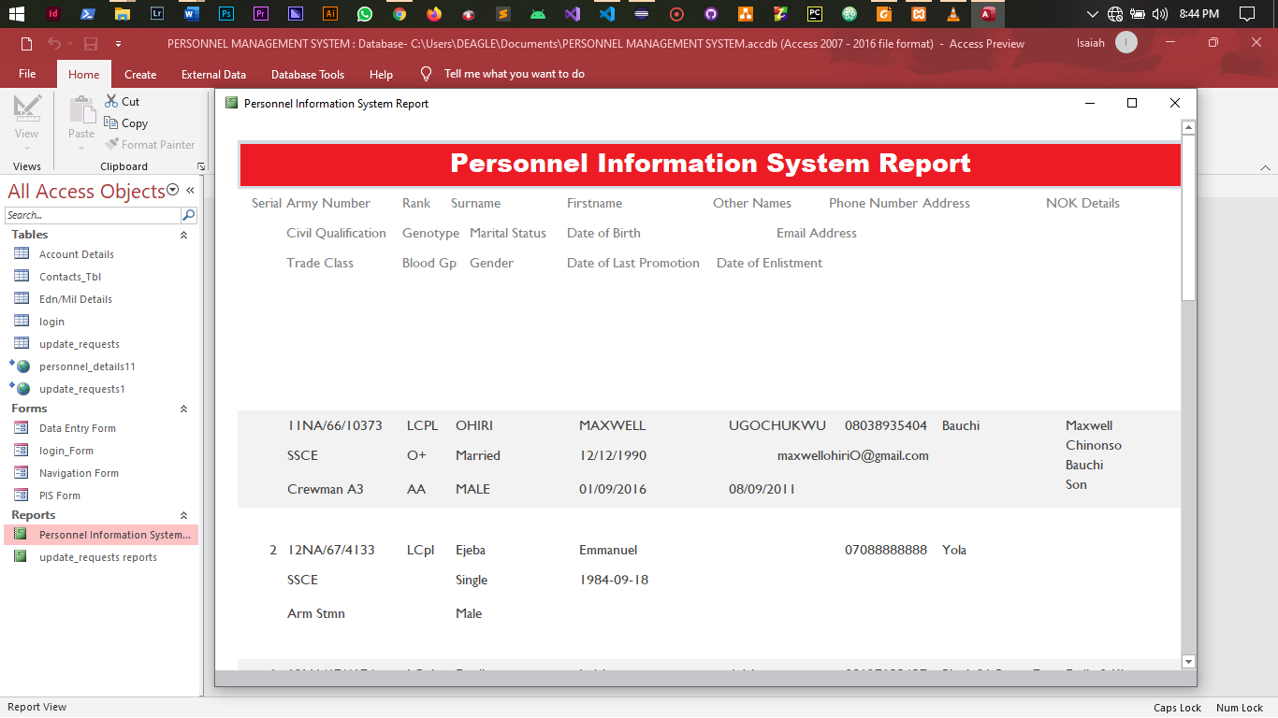

**Figure 6:** PIS Report Page